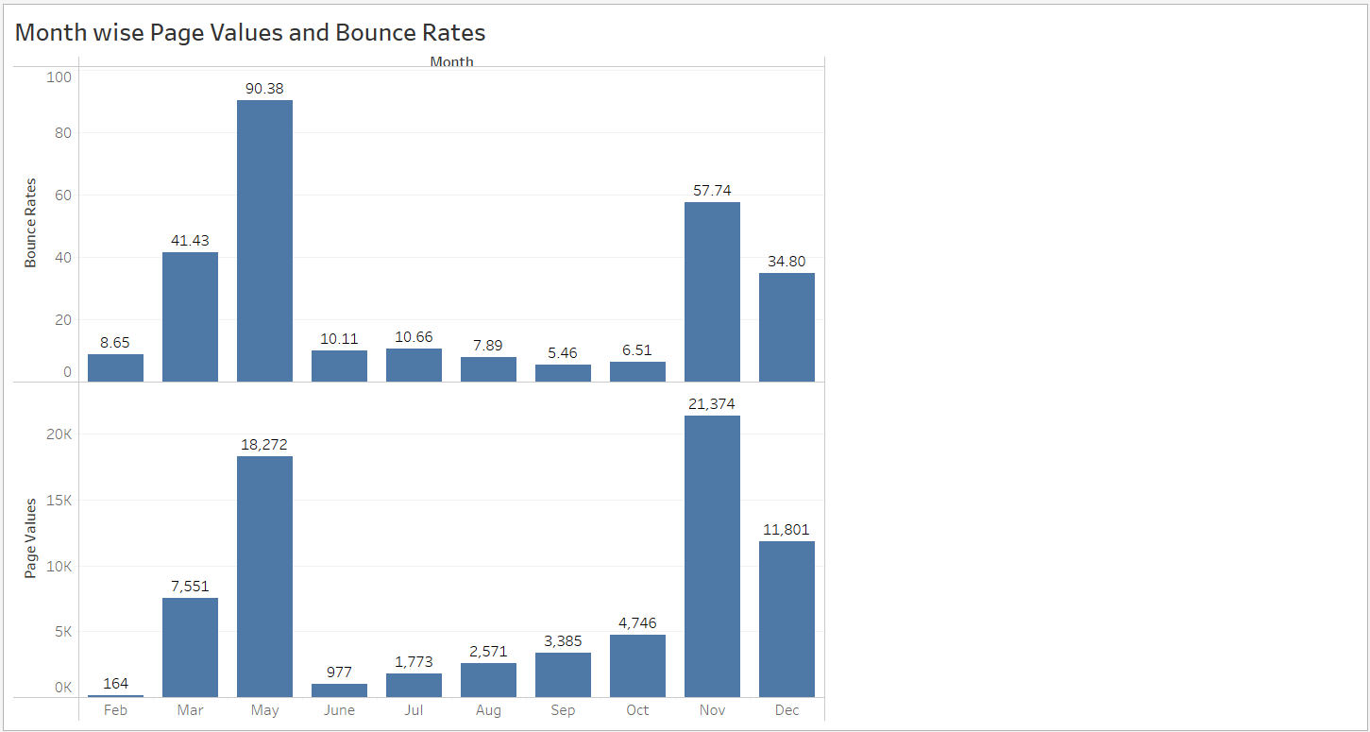

**Analyze this data and understand the performance of page views and bounce rates for each month:**

**Page Views:**

Page views represent the total number of times a page on your website has been viewed by visitors.

**Bounce Rate:**

Bounce rate is a percentage of visitors who land on a page and then leave your website without interacting with it further.

* + - * + February month page values **164** and bounce rate is **8.65%.**
        + March month page values **7,551** and bounce rate is **41.43%.**
        + May month page values **18,272** and bounce rate is **90.38%.**
        + June month page values **977** and bounce rate is **10.11%.**
        + July month page values **1,773** and bounce rate is **10.66%.**
        + August month page values **2,571** and bounce rate is **7.89%.**
        + September month page values **3,385** and bounce rate is **5.46%.**
        + October month page values **4,746** and bounce rate is **6.51%.**
        + November month page values **21,374** and bounce rate is **57.74%.**
        + December month page values **11,801** and bounce rate is **34.80%.**

**High page views with Low Bounce:**

September, October months has high page views and a low bounce rate. It’s a strong indication of good performance as it means a large audience is engaged.

**Consistent Growth:**

July, August, September, October and November months increasing page views over time along with an average bounce rate is a positive sign for your website.

**Low Bounce Rate:**

Months with lower bounce rates, such as February, June, July, August, September and October visitors that engaging the website.